SWE40006 - Software Deployment and Evolution
Deployment Portfolio Task 2

Student Name: Nguyen Huyen Minh Nhat
Student ID: 105550225
Unit: SWE40006 - Software Deployment and Evolution
Semester: Fall 2026
Due Date: 05 October 2026, 23:59
Submission Date: 05 October 2026

Table of Contents
1. Task Level Attempted 2
2. Introduction 2
3. Initial EC2 and WordPress Deployment 2
4. External Database, Load Balancer and Backup/Restore 5
5. Application Load Balancer 10
6. Launch Template and Auto Scaling 11
7. Windows SSH Access and CLI Verification 14
8. Errors and Resolutions 15
a) Error 01 - SSH key path not found 15
b) Error 02 - WordPress database connection failure 15
c) Error 03 - ALB endpoint initially unreachable 16
d) Error 04 - Incorrect CLI command 16
9. Public Verification Endpoint and Deployment Resources 17
10. Source Code and Deployment Commands 17
11. Conclusion 17

1. Task Level Attempted
I am attempting Task 2 at Level 2.4 (High Distinction). The work includes the requirements of Levels 2.1, 2.2 and 2.3, with EC2, RDS, S3, Elastic Load Balancing, Launch Template, Auto Scaling Group and Windows SSH access demonstrated.

2. Introduction
The WordPress application was deployed on Amazon Web Services using an EC2 instance and then extended to use an external Amazon RDS database, an Application Load Balancer and Auto Scaling. The backup and restore requirement was also completed, and the final deployment was verified through the ALB endpoint and command-line access from Windows PowerShell.
The main public verification endpoint is: http://t2-swe40006-alb-2041814639.us-east-1.elb.amazonaws.com

3. Initial EC2 and WordPress Deployment
An EC2 key pair named T2_SWE40006_key and security group T2_SWE40006_SG were created. The security group allowed SSH access from the working client IP and HTTP access for the WordPress service. The WordPress application was installed on an Amazon Linux EC2 instance and verified through Apache.
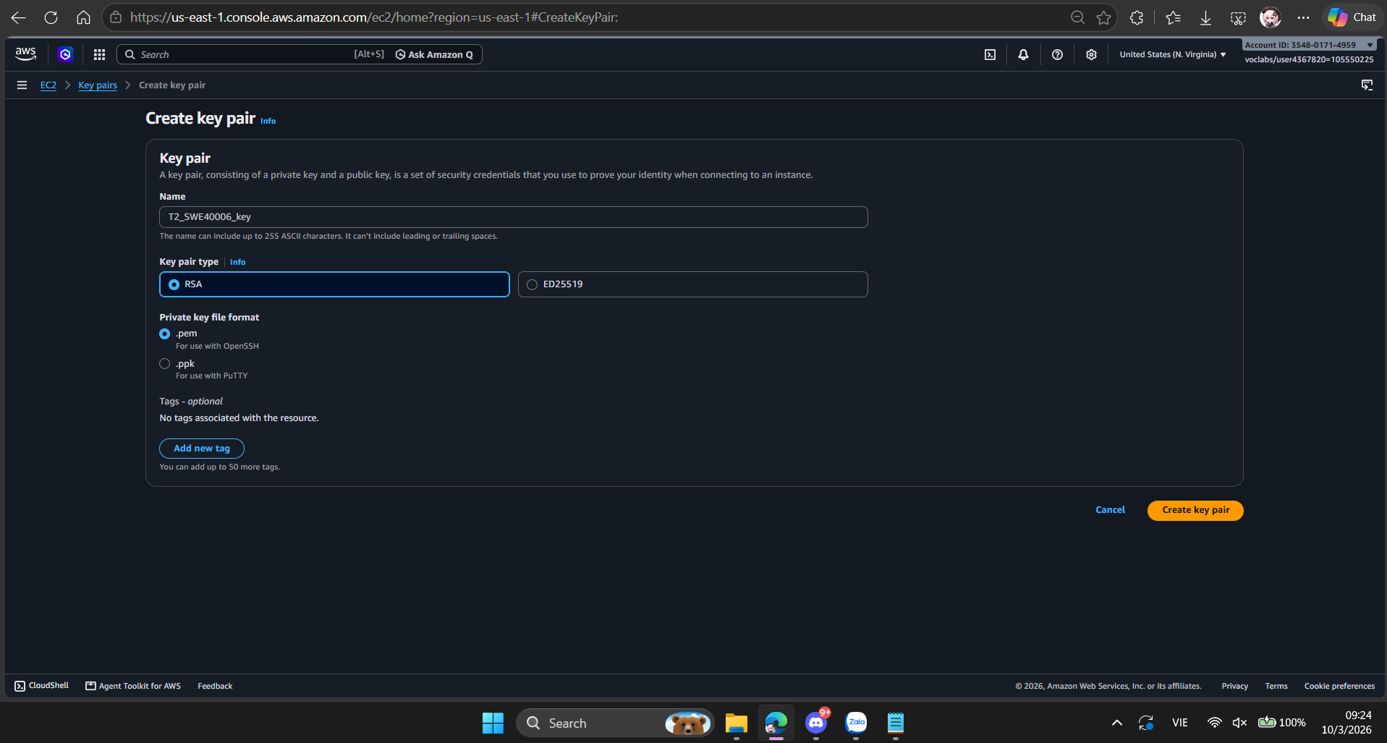
Fig. 1. EC2 SSH key pair T2_SWE40006_key created for instance access.
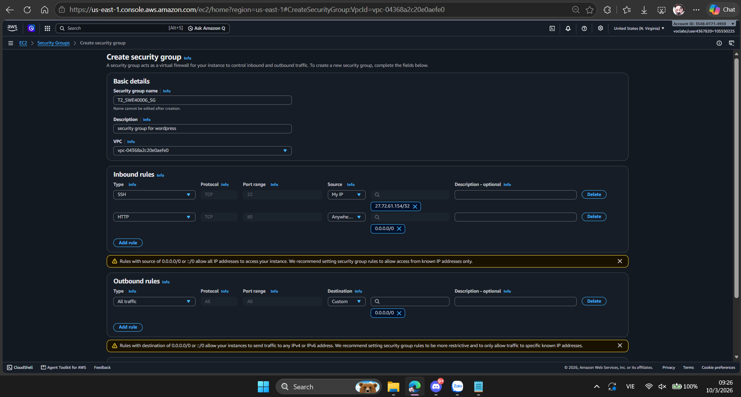
Fig. 2. EC2 security group configured for SSH and HTTP access.

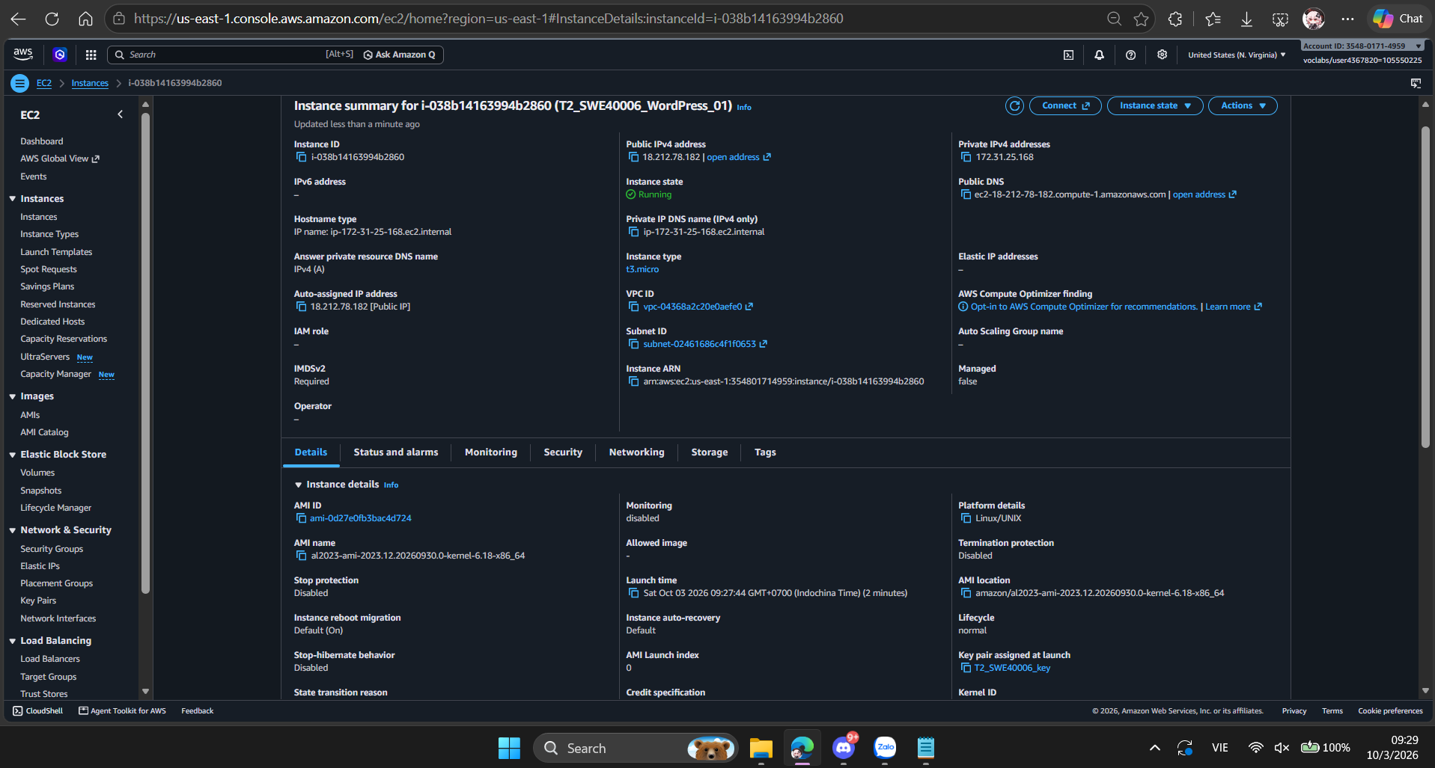
Fig. 3. Initial WordPress EC2 instance configuration.
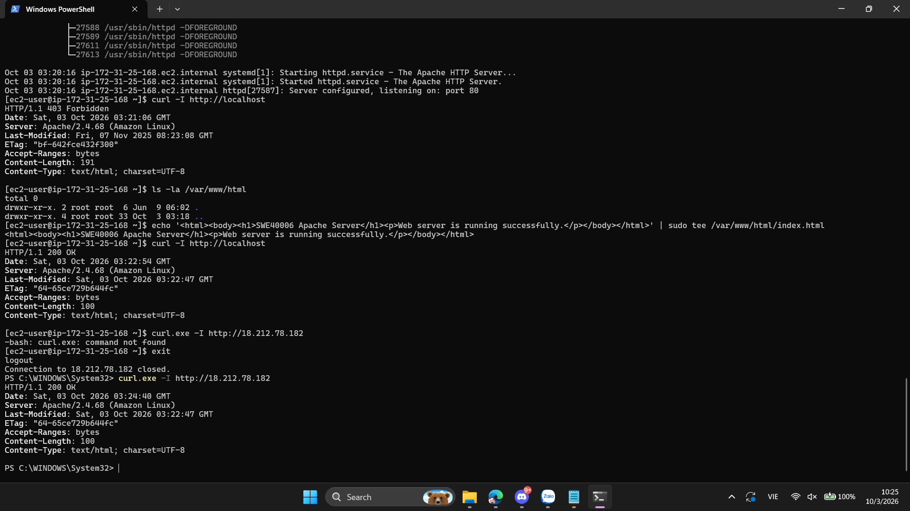
Fig. 4. WordPress successfully served through the EC2 public endpoint.

The initial deployment provided the base EC2 WordPress environment required for the higher task levels.

4. External Database, Load Balancer and Backup/Restore
The EC2 deployment was extended by moving the WordPress database to Amazon RDS. The RDS endpoint was tested from the EC2 instance before the migration. The existing WordPress database was exported with mysqldump, imported into RDS and then configured as the external database in wp-config.php. The migrated database was verified by checking the WordPress tables, posts and user records.
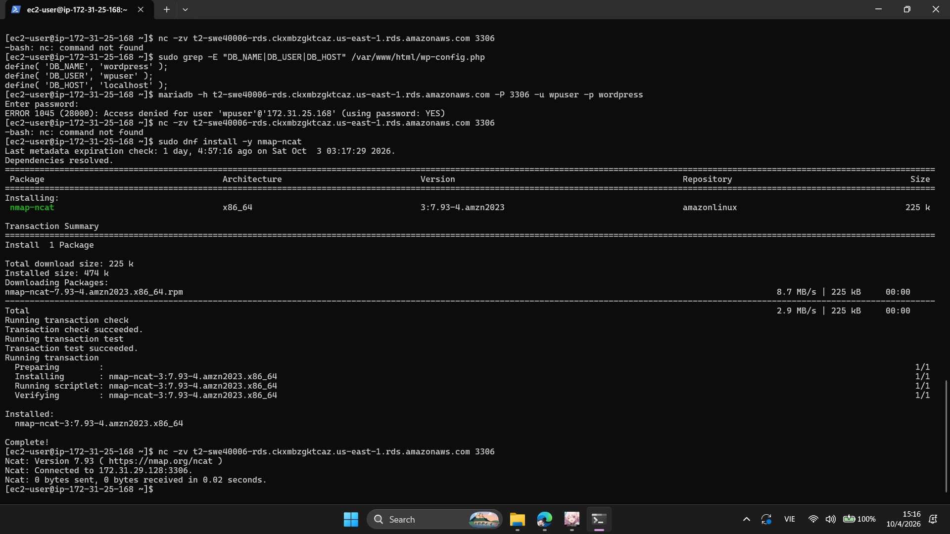
Fig. 5. Connectivity from EC2 to the RDS MySQL endpoint on port 3306.

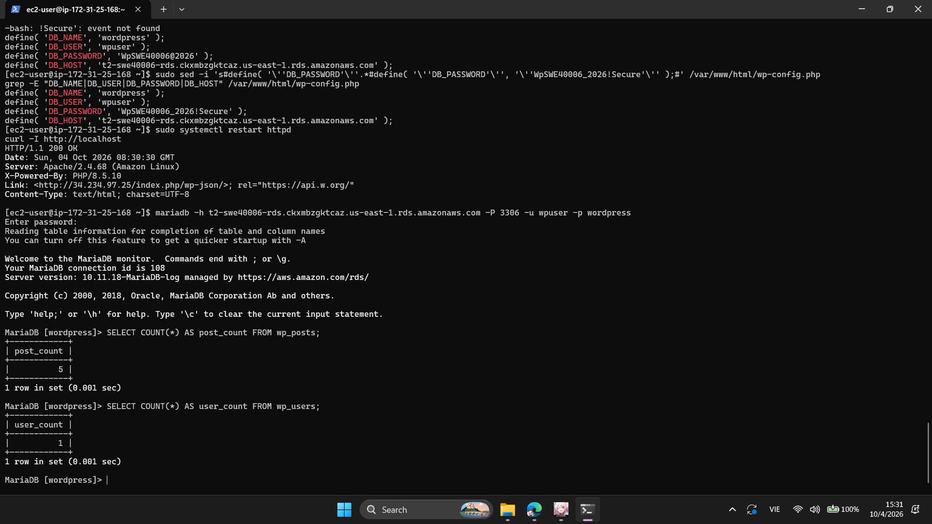
Fig. 6. RDS WordPress database verification showing the migrated tables and records.

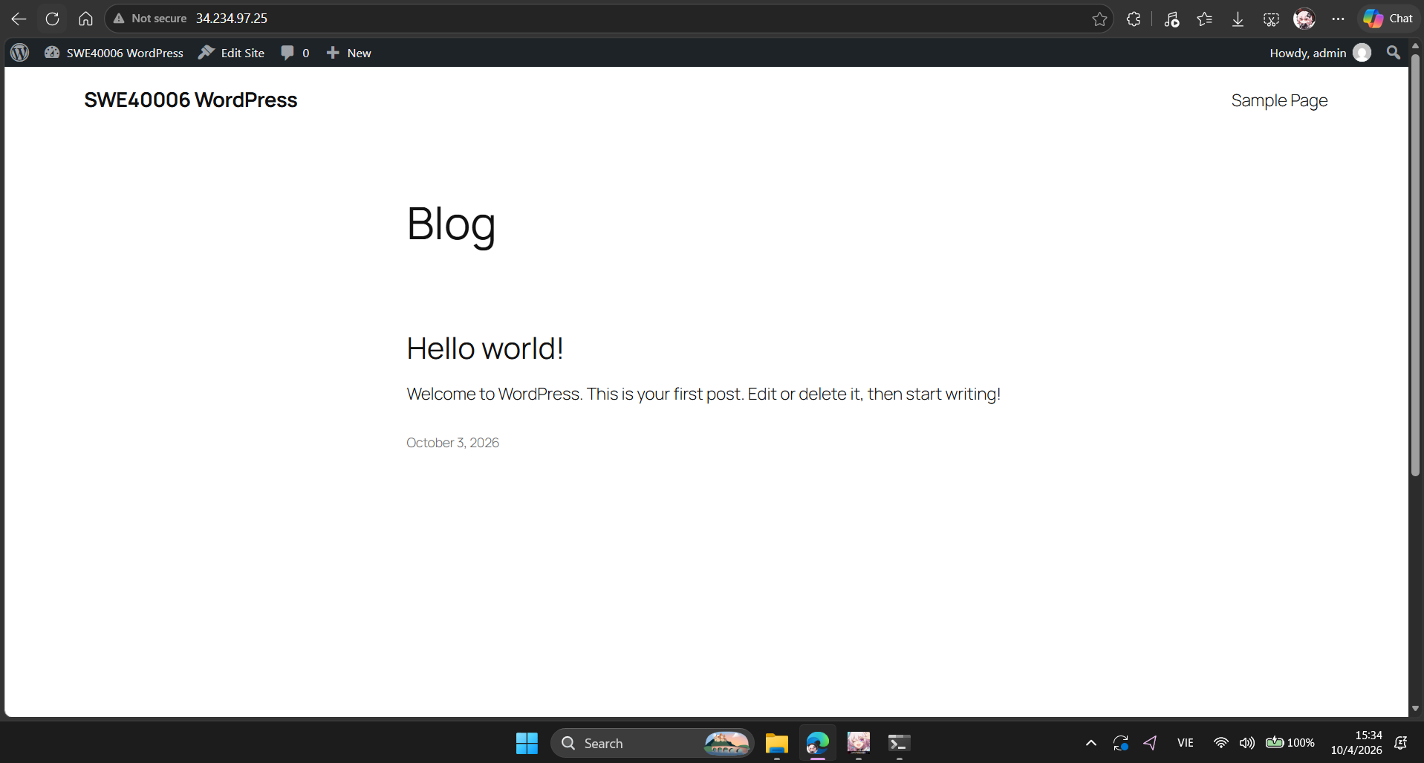
Fig. 7. WordPress successfully operating after migration to the external RDS database.

For the backup and restore requirement, an S3 bucket was created in the same AWS region. An EC2 AMI backup was then created and monitored until it became available. A new EC2 instance was launched from the available backup AMI.
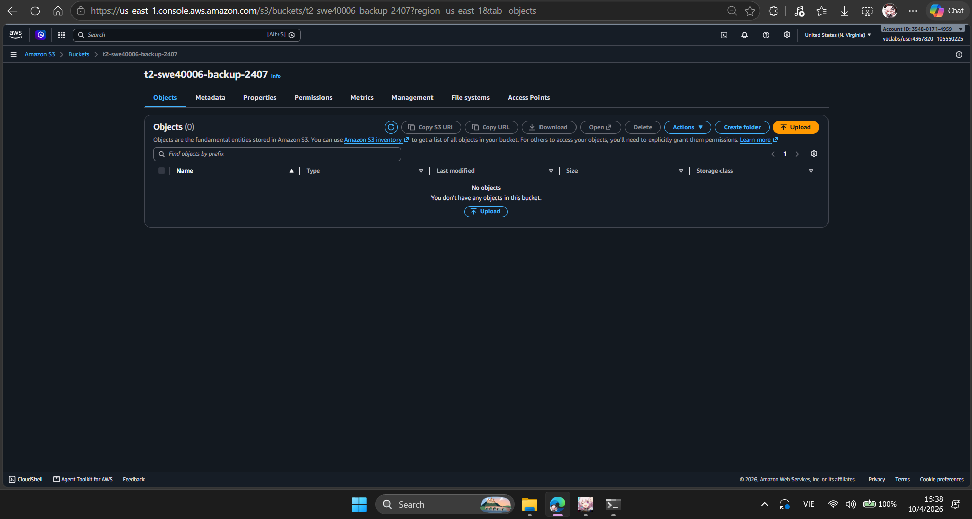
Fig. 8. S3 backup bucket in the AWS region.

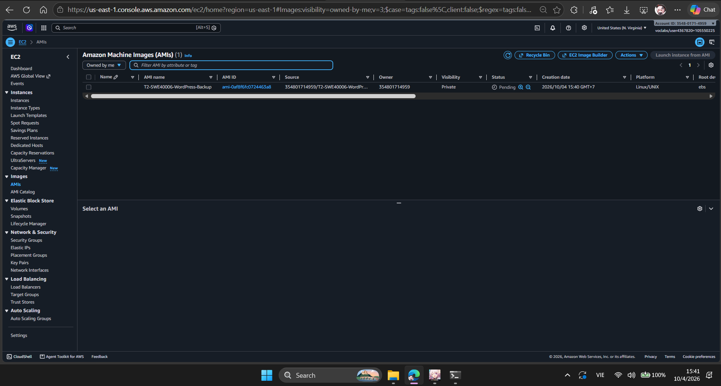
Fig. 9. EC2 backup AMI while the backup operation was in progress.

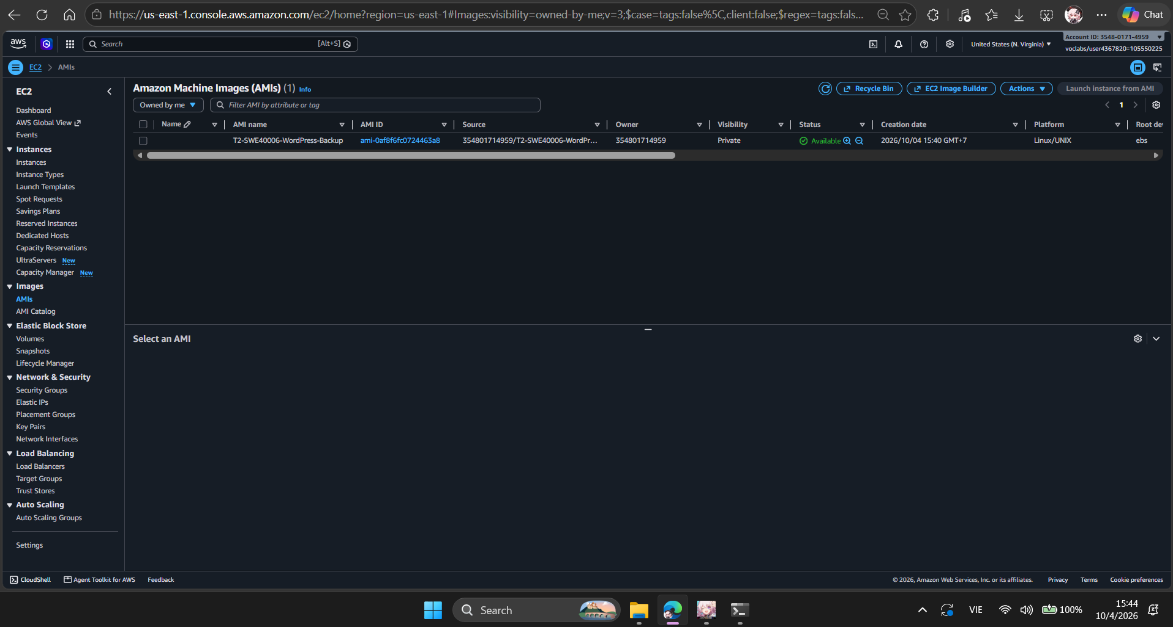
Fig. 10. EC2 backup AMI became available for recovery.

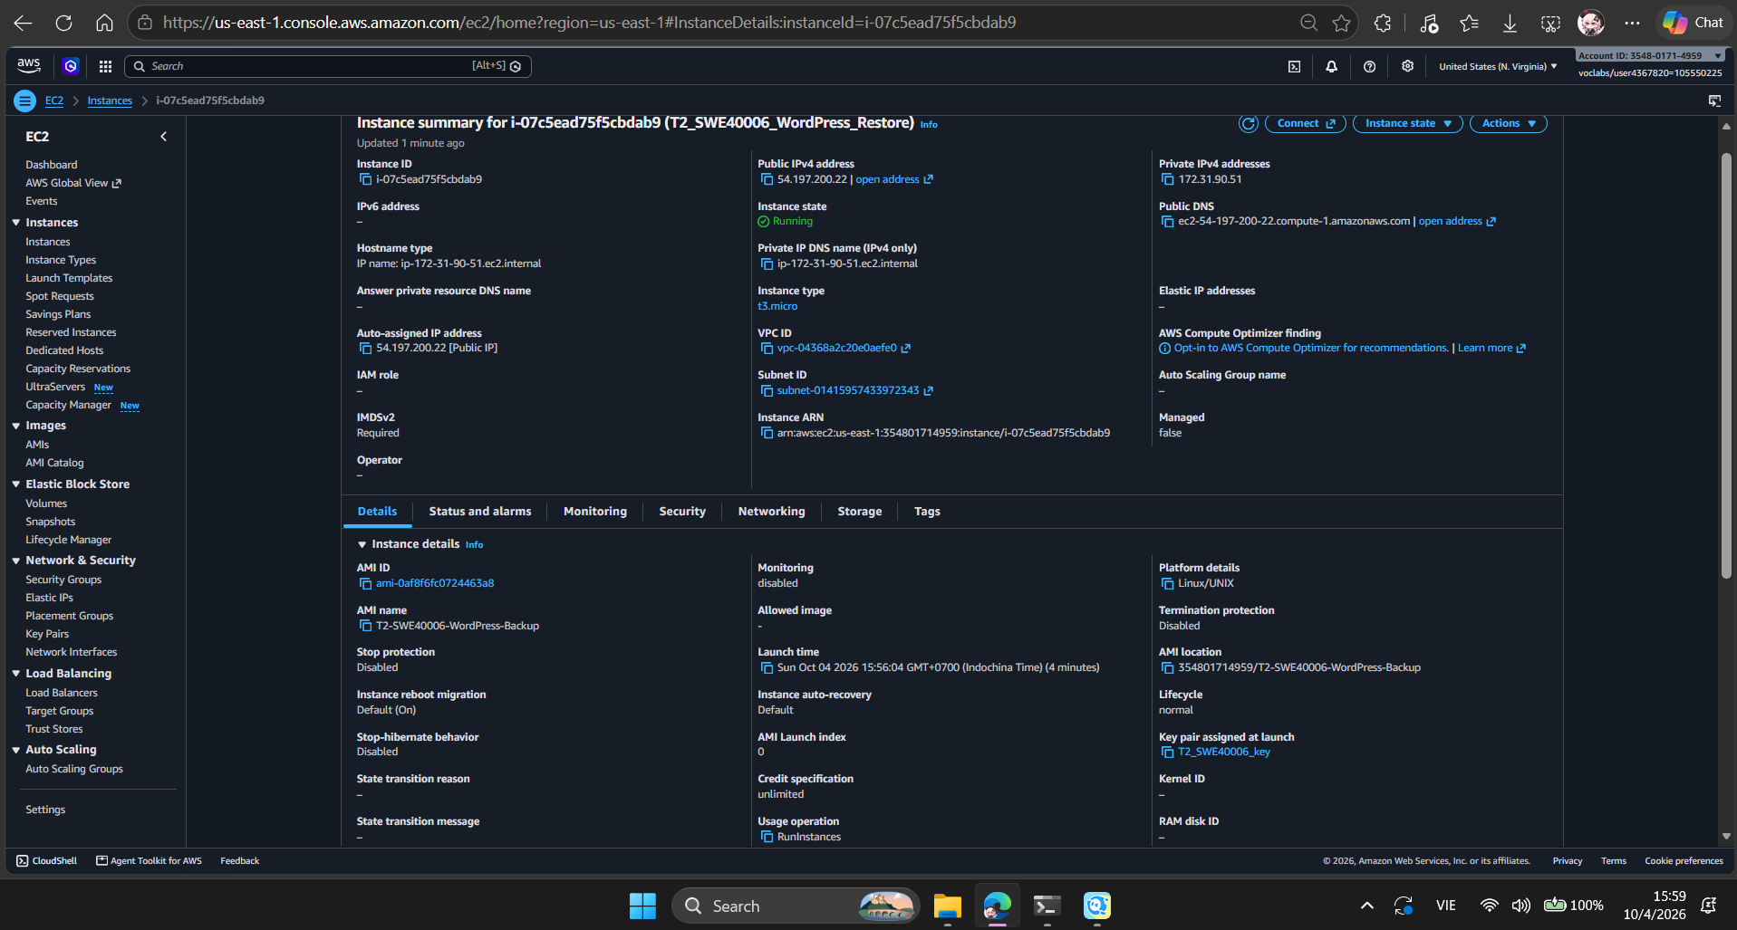
Fig. 11. New WordPress EC2 instance restored from the backup AMI.

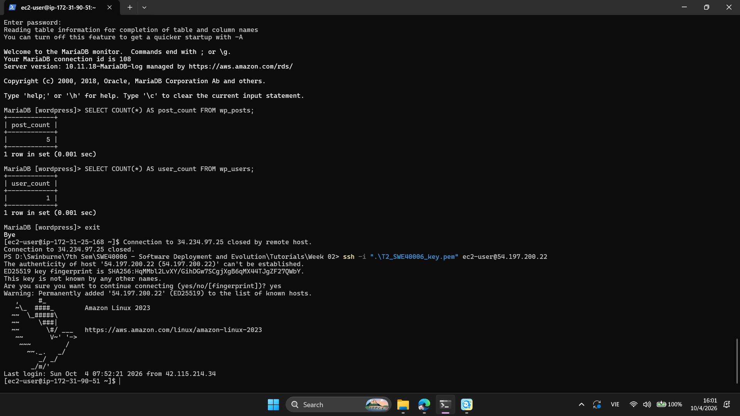
Fig. 12. Successful SSH access to the restored EC2 instance.

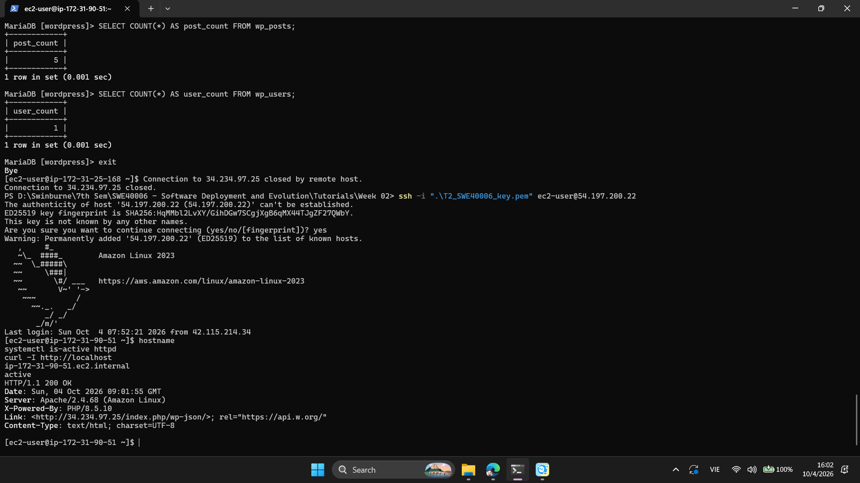
Fig. 13. Restored instance verification showing the Apache service and successful local HTTP response.

The restored instance confirmed that the backup could be used to recreate the WordPress server environment.

5. Application Load Balancer
An internet-facing Application Load Balancer named T2-swe40006-ALB was created with an HTTP listener on port 80. The target group T2-SWE40006-TG was configured to forward requests to the WordPress EC2 instance. After the listener was attached, the target became healthy and WordPress was accessible through the ALB DNS name.
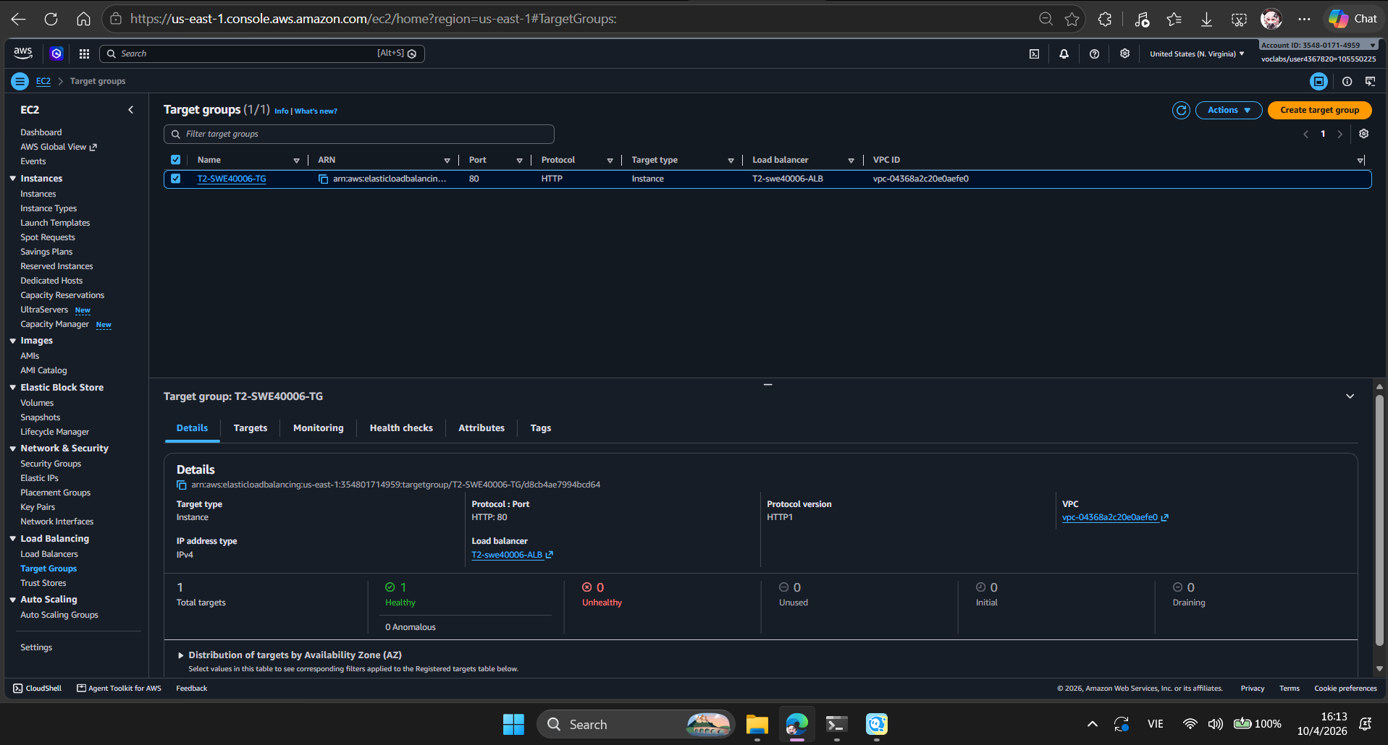
Fig. 14. Target group showing the WordPress EC2 target as healthy.

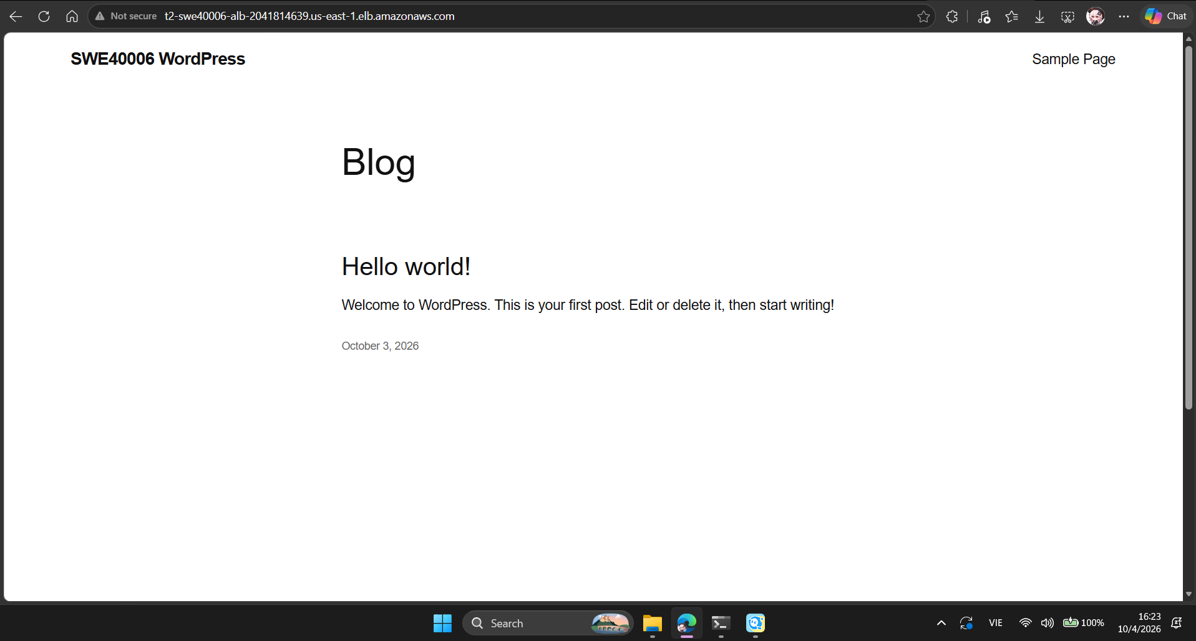
Fig. 15. WordPress successfully accessed through the ALB DNS endpoint using HTTP.

6. Launch Template and Auto Scaling
A Launch Template named T2_SWE40006_LT was created from the WordPress backup AMI. It specifies the t3.micro instance type, the T2_SWE40006_key key pair and the WordPress EC2 security group. The subnet was not fixed in the template so that the Auto Scaling Group could launch instances across the selected subnets.
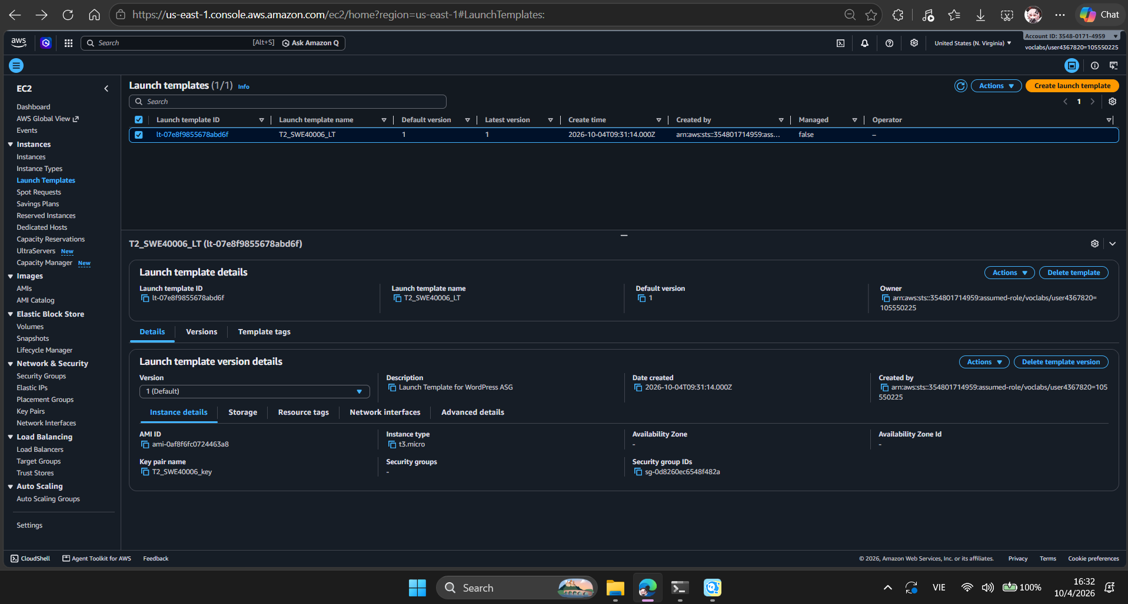
Fig. 16. Launch Template T2_SWE40006_LT created from the WordPress backup AMI.

The Auto Scaling Group T2_SWE40006_ASG was then created using the Launch Template and attached to the existing ALB target group. The group was configured with minimum capacity 1, desired capacity 1 and maximum capacity 2. CPU target tracking was configured at 50%.

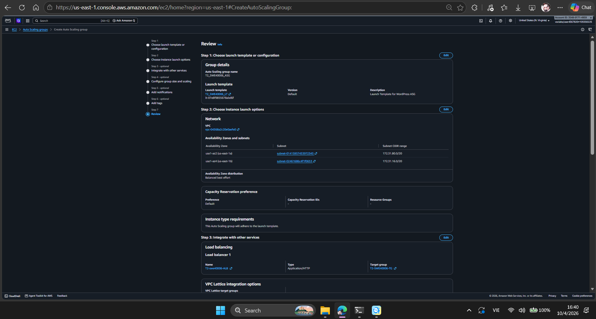
Fig. 17. Auto Scaling Group configuration showing the Launch Template, networking and load balancer attachment.
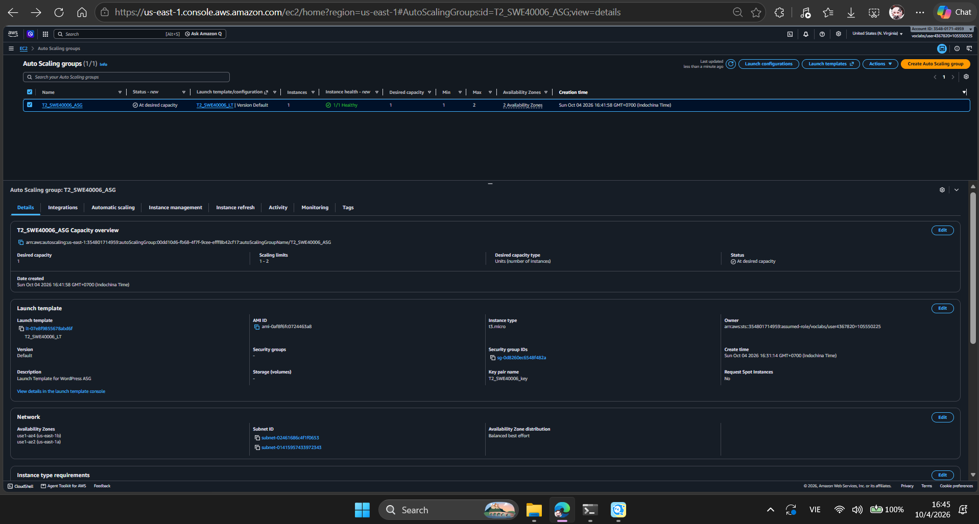
Fig. 18. Auto Scaling Group launched one healthy EC2 instance at the desired capacity.

To test scaling, the desired capacity was increased from one to two instances. The ASG launched the second instance and both instances were reported healthy. The target tracking policy then reduced desired capacity from two to one when CPU utilisation remained below the 50% target. This demonstrated the ASG scaling behaviour.

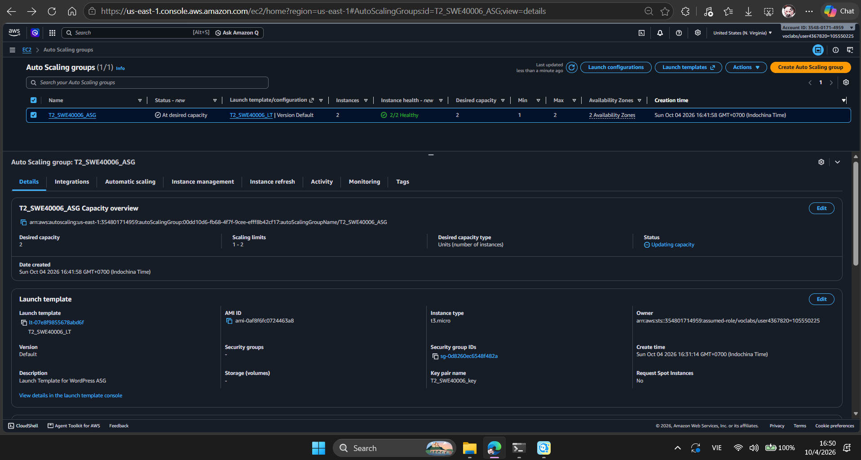
Fig. 19. Auto Scaling Group successfully running two healthy instances during the scale-out test.
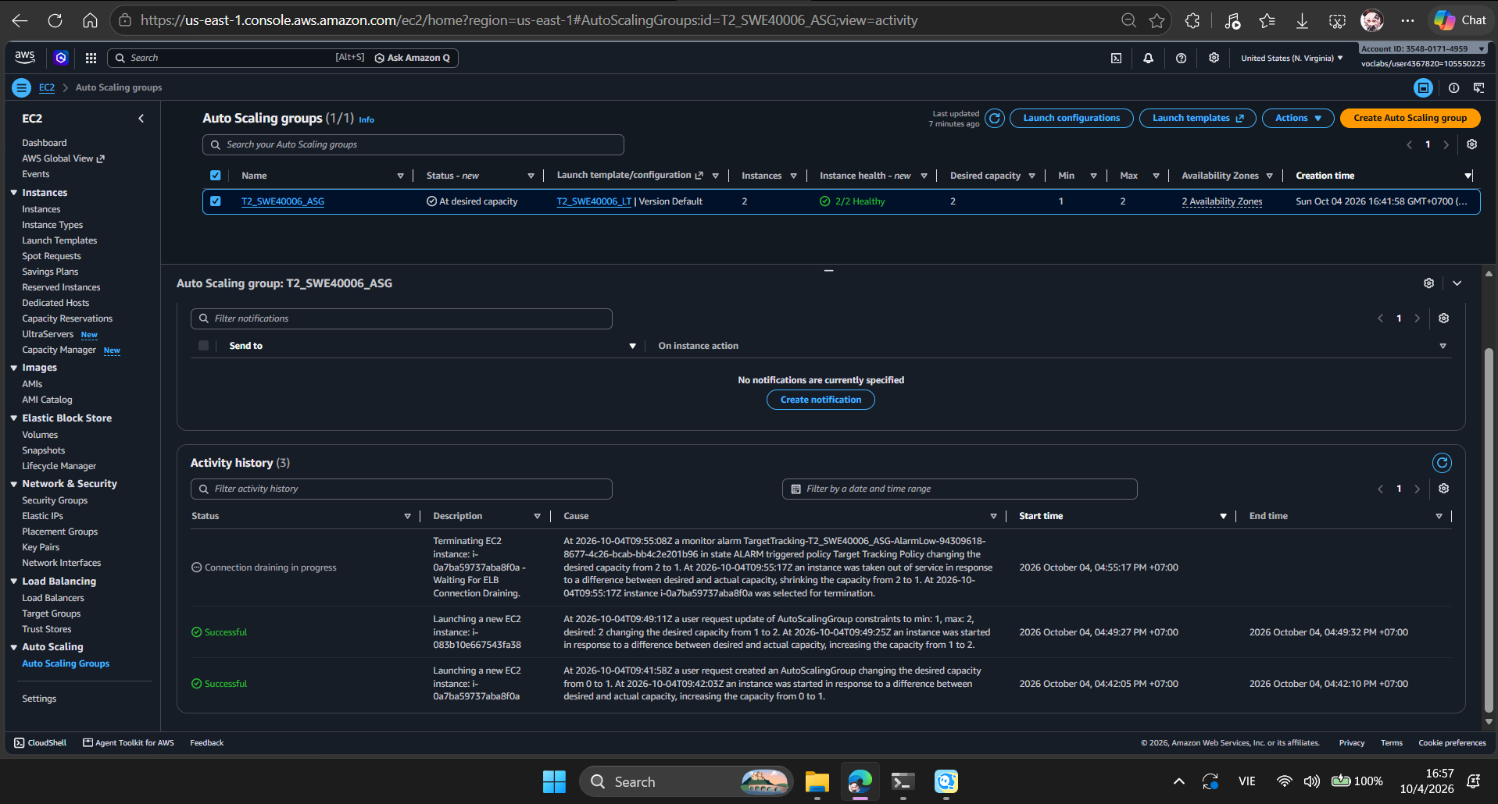
Fig. 20. ASG activity history showing the scaling actions and target tracking policy.

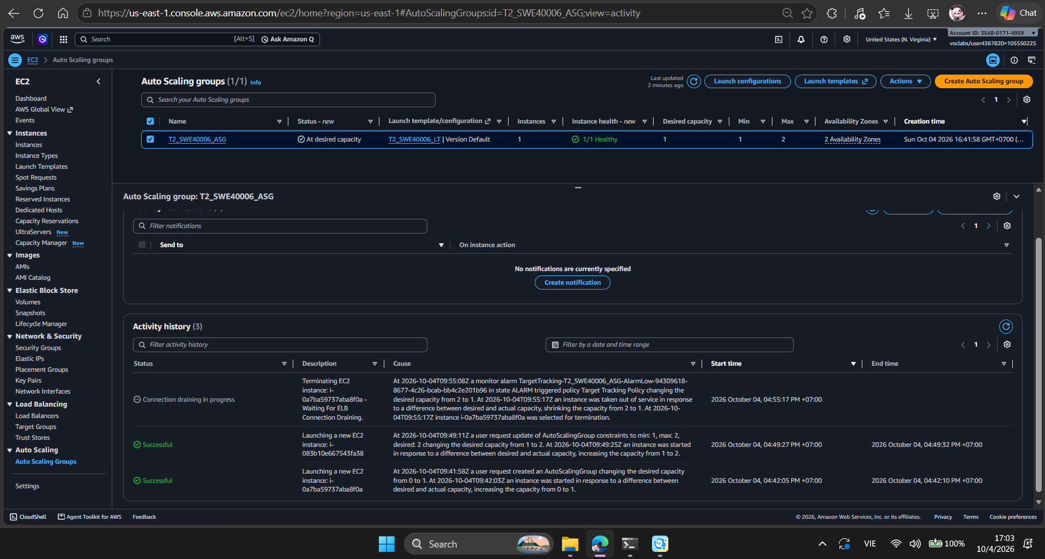
Fig. 21. ASG returned to one healthy instance after automatic scale-in.

7. Windows SSH Access and CLI Verification
For the HD requirement, SSH access was demonstrated from Windows PowerShell to the restored Linux EC2 instance using the T2_SWE40006_key.pem key. The connection succeeded and the Amazon Linux shell was used to run several verification commands.
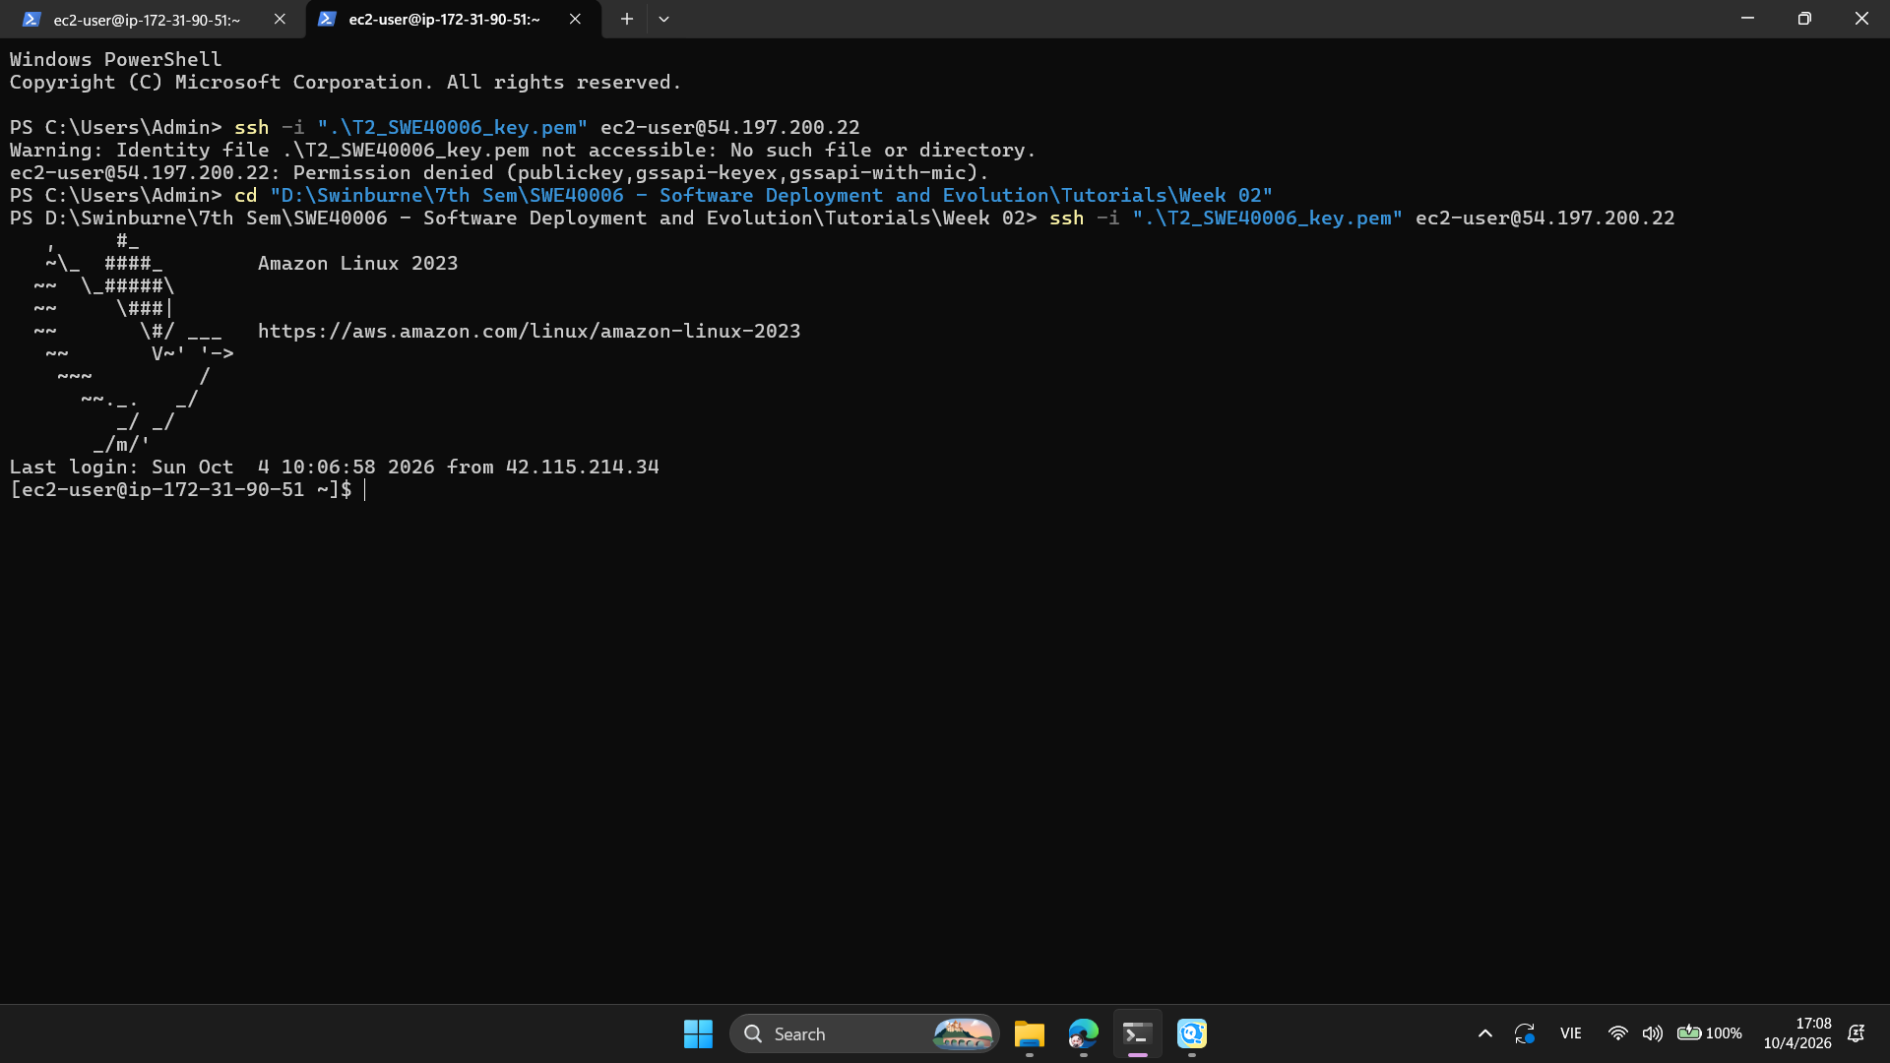
Fig. 22. Successful SSH connection from Windows PowerShell to the restored AWS EC2 instance.

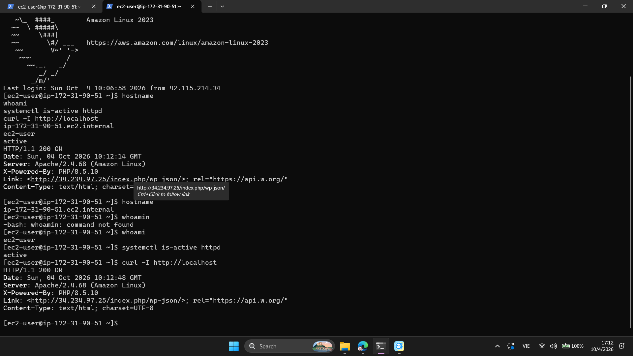
Fig. 23. Windows SSH CLI interactions verifying hostname, user, Apache service status and HTTP response.

The commands confirmed the instance hostname as ip-172-31-90-51.ec2.internal, the logged-in user as ec2-user, the Apache service status as active and the local HTTP response as HTTP/1.1 200 OK. A minor command-entry error, whoamin, was also identified and corrected to whoami.

8. Errors and Resolutions
The deployment issues encountered during Task 2 were investigated and corrected rather than omitted from the report.

a) Error 01 - SSH key path not found
Problem: The first SSH command was executed from a directory that did not contain T2_SWE40006_key.pem. PowerShell reported that the identity file could not be found and the SSH authentication failed.
Resolution: The working directory was changed to the folder containing the key file. The same SSH command was then executed successfully.
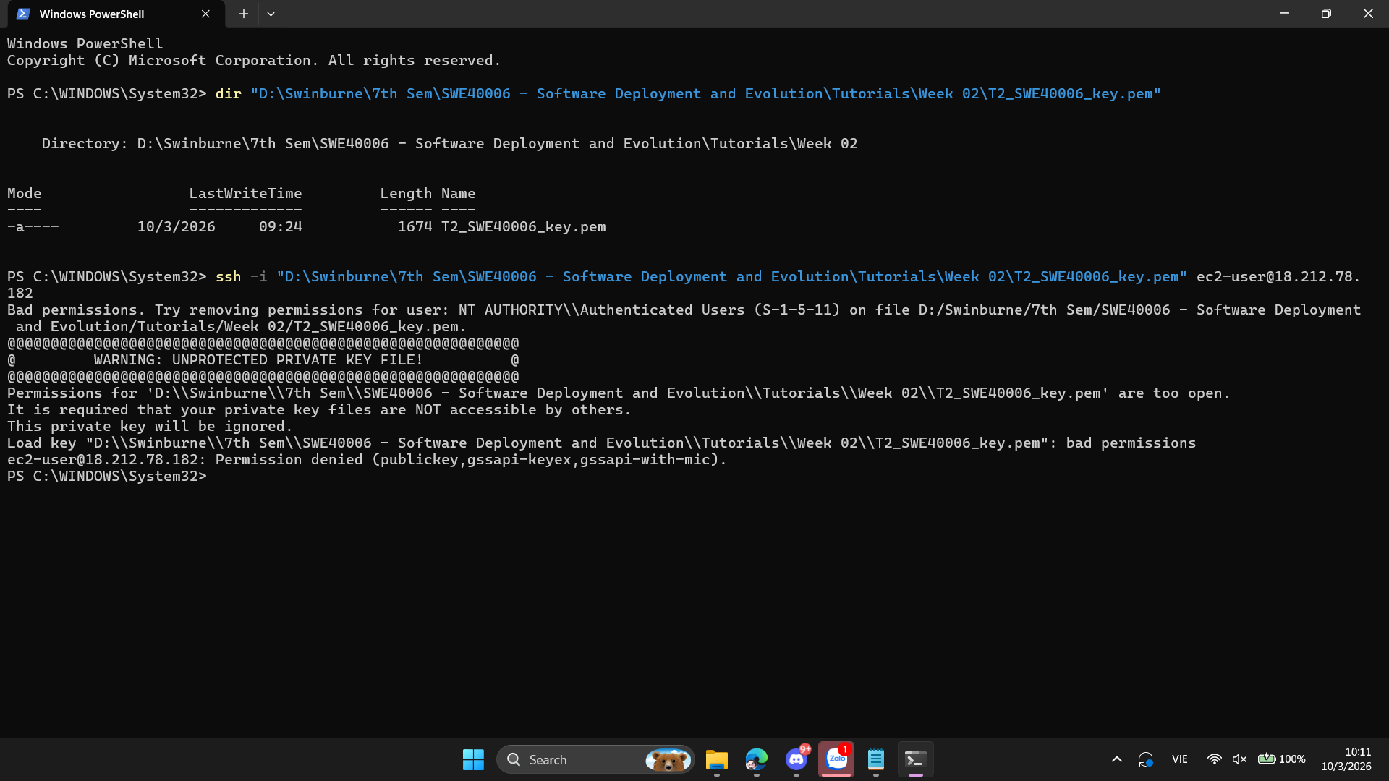
Fig. 24. Initial SSH failure caused by an incorrect local key-file path.

b) Error 02 - WordPress database connection failure
Problem: During the database migration, WordPress temporarily displayed an error establishing a database connection while the external RDS configuration was being completed.
Resolution: RDS connectivity was tested from EC2, the WordPress database was imported into RDS, the RDS WordPress user privileges were configured and wp-config.php was updated to use the RDS endpoint. WordPress was then retested successfully.
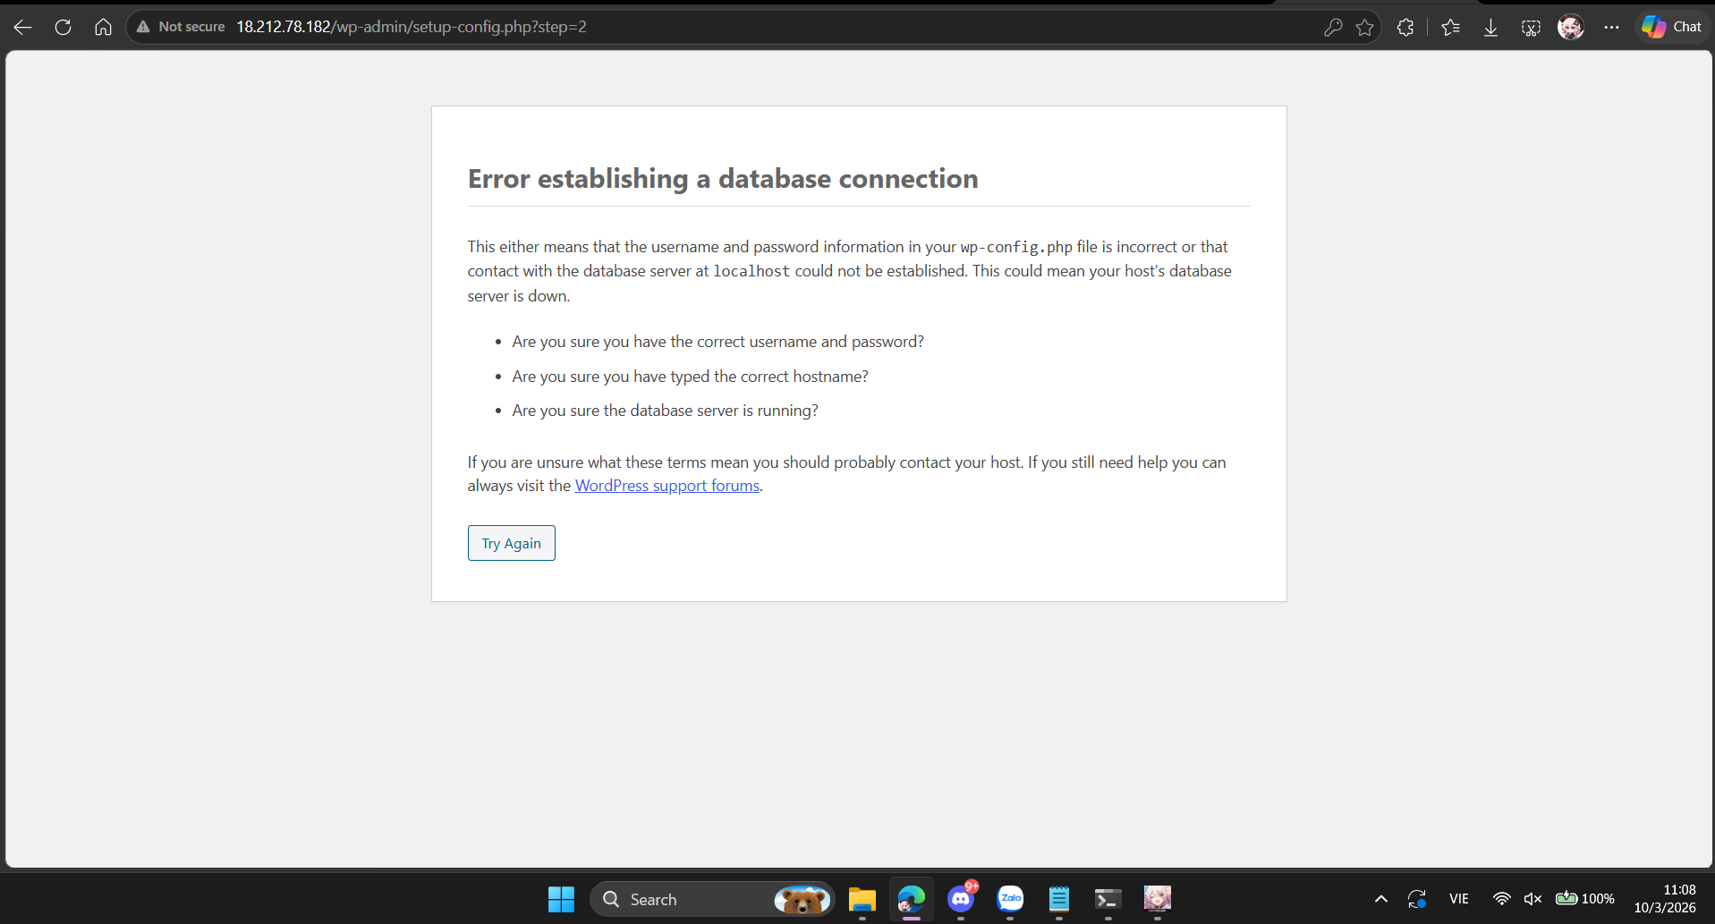
Fig. 25. WordPress database connection error encountered during the RDS migration.

c) Error 03 - ALB endpoint initially unreachable
Problem: The ALB endpoint initially appeared unreachable when it was opened with the wrong protocol. The browser displayed a connection timeout.
Resolution: The ALB listener was checked and confirmed to use HTTP on port 80. The endpoint was then accessed explicitly with http:// and WordPress loaded successfully through the load balancer.
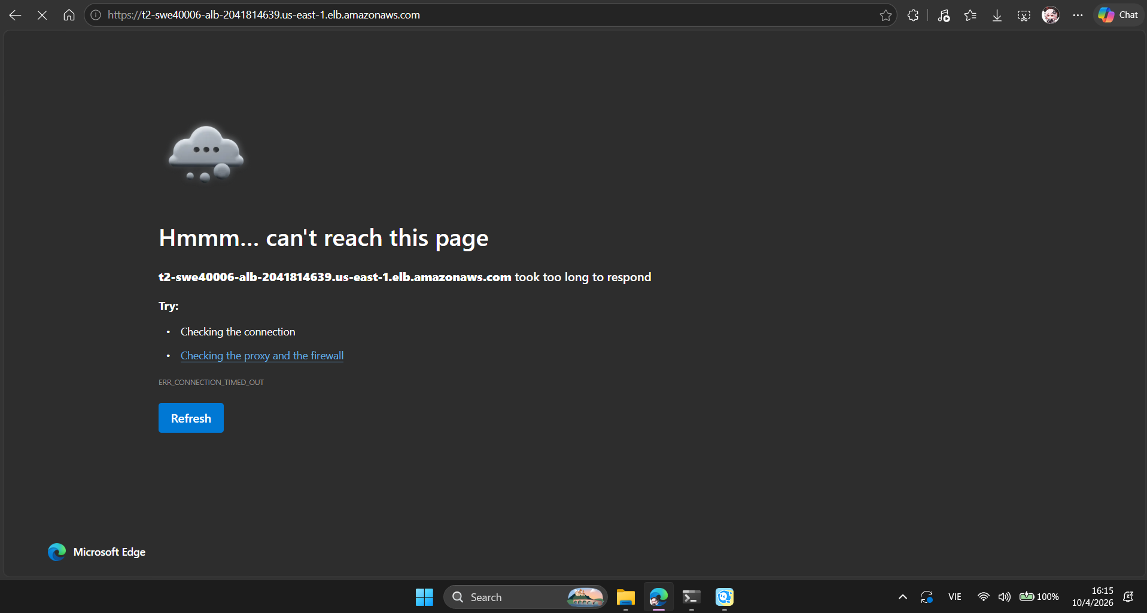
Fig. 26. Initial ALB access error before using the correct HTTP listener.

d) Error 04 - Incorrect CLI command
Problem: During the HD CLI verification, whoamin was entered instead of whoami and Bash returned command not found.
Resolution: The command was corrected to whoami and returned ec2-user. The remaining verification commands completed successfully.

9. Public Verification Endpoint and Deployment Resources
The deployed WordPress service can be verified publicly through the Application Load Balancer:
Public URL: http://t2-swe40006-alb-2041814639.us-east-1.elb.amazonaws.com
The restored EC2 instance used for SSH verification had public IPv4 address 54.197.200.22 at the time of testing. The ALB DNS endpoint is the preferred public verification endpoint because it represents the load-balanced deployment.
S3 backup bucket | Created in us-east-1
Resource | Configuration / identifier
Region | us-east-1
EC2 key pair | T2_SWE40006_key
EC2 security group | T2_SWE40006_SG
RDS endpoint | t2-swe40006-rds.ckxmbzgktcaz.us-east-1.rds.amazonaws.com
Target group | T2-SWE40006-TG
Load balancer | T2-swe40006-ALB
Launch Template | T2_SWE40006_LT
Auto Scaling Group | T2_SWE40006_ASG
EC2 backup AMI | T2-SWE40006-WordPress-Backup

10. Source Code and Deployment Commands
Task 2 did not require custom application source code. The WordPress application and deployment infrastructure were configured using AWS services and Linux command-line tools. The command-line interactions used for verification are shown in the report screenshots. No binaries or private credentials are included in the report.

11. Conclusion
The WordPress deployment was successfully completed on AWS at Level 2.4. The deployment progressed from a single EC2 instance to an external RDS database, an Application Load Balancer, backup and restore, a Launch Template and an Auto Scaling Group. Scaling was tested from one to two instances and the target tracking policy subsequently performed automatic scale-in. Windows PowerShell SSH access and multiple CLI interactions were also demonstrated. The deployment issues encountered during the work were investigated, corrected and retested.

